BUSWELLS LODGE PRIMARY SCHOOL

PUPIL PREMIUM STRATEGY STATEMENT 2026-2029

This statement details our school’s use of pupil premium funding to help improve the attainment of our disadvantaged pupils.
It outlines our pupil premium strategy, how we intend to spend the funding in this academic year and the outcomes for disadvantaged pupils last academic year.

School overview
Detail | Data
Number of pupils in school | 325
Proportion (%) of pupil premium eligible pupils | 37%
Academic year/years that our current pupil premium strategy plan covers | 2026-2029
Date this statement was published | September 2026
Date on which it will be reviewed | September 2027
Statement authorised by | Adrian Durrant
Pupil premium lead | Adrian Durrant
Governor / Trustee lead | Lynn Wyeth

Funding overview
Detail | Amount
Pupil premium funding allocation this academic year | £265,600
Pupil premium funding carried forward from previous years (enter £0 if not applicable) | £0
Total budget for this academic year | £265,600

Part A: Pupil premium strategy plan

Statement of intent
At Buswells Lodge Primary School, we are committed to ensuring that disadvantage does not determine destiny. Our pupil premium strategy is rooted in a clear understanding of our school context, where many pupils face significant socio-economic challenges, high levels of vulnerability, barriers to attendance, and limited access to wider cultural and educational opportunities. We recognise that many disadvantaged pupils may also have SEND, social care involvement, EAL needs, or additional vulnerabilities that can compound barriers to learning.
Our approach is built on the principle of providing the right support, at the right time, for the right pupils. We prioritise high-quality teaching as the most effective lever for improving outcomes, whilst supplementing this with targeted academic interventions, robust pastoral support, family engagement, attendance improvement strategies and enriched personal development opportunities.
Through a relentless focus on reading, writing, mathematics, communication and language, inclusion, attendance and personal development, we aim to remove barriers, raise aspirations and ensure that disadvantaged pupils achieve well from their starting points. We will use evidence-informed approaches, regular monitoring and careful evaluation to ensure funding has maximum impact and that pupils are fully prepared for the next stage of their education and future lives.
Specifically, we will ensure that we:
- Deliver consistently high-quality, evidence-informed teaching through adaptive practice, precise assessment and targeted professional development in reading, vocabulary, communication and language, SEND and inclusion.
- Provide timely, data-informed interventions in reading, writing and mathematics to identify gaps early and accelerate progress for disadvantaged pupils who are at risk of underachievement.
- Implement robust attendance monitoring, early intervention and personalised support, working closely with families and external agencies to address barriers and reduce persistent absence.
- Provide coordinated pastoral, wellbeing, safeguarding and SEND support to ensure vulnerable pupils can engage fully in learning and achieve positive outcomes.
- Build strong partnerships with families through proactive communication, learning support and access to external services, improving engagement, attendance and educational outcomes.
- Ensure all disadvantaged pupils can access a wide range of enrichment opportunities, educational visits, clubs, leadership roles and aspirational experiences that broaden horizons and prepare them for future success.

Challenges
This details the key challenges to achievement that we have identified among our disadvantaged pupils.
Challenge number | Detail of challenge
1 | Low Starting Points and Foundational Gaps  Many pupils enter school significantly below age-related expectations, particularly in communication and language, vocabulary, self-regulation and early literacy skills.
2 | Reading, Writing and Mathematical Fluency  Many disadvantaged pupils experience gaps in reading fluency, comprehension, vocabulary development, writing outcomes and mathematical fluency. Limited access to books, literacy-rich experiences and opportunities to practise key skills outside school can hinder the development of both literacy and numeracy, affecting confidence, attainment and progress across the wider curriculum.
3 | Attendance and Persistent Absence  A significant proportion of disadvantaged pupils face attendance barriers linked to family circumstances, health needs, poor routines and wider social challenges. Persistent absence remains a key obstacle to academic success.
4 | Social, Emotional and Mental Health Needs  High levels of deprivation and vulnerability contribute to increased emotional, behavioural and wellbeing needs. Some pupils require additional pastoral support, self-regulation strategies and intervention to enable them to engage successfully in learning.
5 | Cultural Capital, Enrichment and Family Engagement  Many disadvantaged pupils face barriers to accessing wider cultural, enrichment and extracurricular opportunities, including educational visits, clubs, community activities and experiences that broaden aspirations and personal development. Some families also experience challenges relating to employment, housing, routines, attendance and confidence in supporting learning, which can further impact pupils' engagement, wellbeing and educational outcomes. Together, these factors can limit pupils' readiness to learn, participation in school life and opportunities to develop the knowledge, skills and cultural capital needed for future success.

Intended outcomes
This explains the outcomes we are aiming for by the end of our current strategy plan, and how we will measure whether they have been achieved.
Intended outcome | Success criteria
Academic attainment | - Disadvantaged pupils achieve at least in line with their non-disadvantaged peers from similar starting points.  - Gaps in reading attainment, reading fluency and comprehension continue to diminish.  - More disadvantaged pupils meet age-related expectations in writing through improved vocabulary, sentence construction and writing stamina.  - Disadvantaged pupils demonstrate improved mathematical fluency and confidence across all year groups.  - Pupils who are significantly below age-related expectations make accelerated progress through targeted support and intervention.
Attendance and Engagement | - Attendance of disadvantaged pupils increases to above 94.5%  - Persistent absence among disadvantaged pupils is significantly reduced to from 23.2% to below 13%  - Identified attendance barriers are addressed through early intervention, family support and multi-agency working.  - Disadvantaged pupils engage positively with school routines and demonstrate strong attitudes towards learning.
Inclusion and Wellbeing | - Disadvantaged pupils with SEND or additional vulnerabilities receive timely and effective support.  - Pupils demonstrate improved resilience, independence and self-regulation.  - Pupils report feeling safe, supported and able to access help when needed.  - Pastoral interventions show positive impact on attendance, behaviour, wellbeing and engagement
Personal Development | - All disadvantaged pupils access a broad range of enrichment opportunities, visits, clubs and leadership roles  - Participation rates for disadvantaged pupils in extracurricular activities increase so that all disadvantaged pupils attend at least one activity.  - Pupils develop cultural capital, aspirations and confidence through wider curriculum experiences.  - Pupils demonstrate understanding of British Values, diversity and their role as active citizens.
Family and Community Engagement | - Parent engagement improves through workshops, community partnerships and targeted support programmes.  - Families feel well supported and able to access services that reduce barriers to education.  - Stronger home-school relationships contribute to improved attendance, learning and wellbeing outcomes for disadvantaged pupils.

Activity in this academic year
This details how we intend to spend our pupil premium funding this academic year to address the challenges listed above.

Teaching (for example, CPD, recruitment and retention)

Budgeted cost: £179,610.59
Activity | Evidence that supports this approach | Challenge number(s) addressed
Quality First Teaching focus on improving foundational skills in English and Maths so that they can be applied independently across the curriculum  - Planned staff in-house CPD on Reading, Writing and Maths  - Monitoring and bespoke support by SLT  Cost = £179,610.59 | 1. EEF Effective Professional Development (2021)  - High-quality teaching is the most important school-based factor in improving pupil outcomes, and effective professional development is a key mechanism for improving teaching quality, particularly for disadvantaged pupils.  2. EEF Teacher Feedback Guidance (2021)  - Effective formative assessment and feedback help teachers identify learning gaps and adapt teaching to improve pupil progress.  3. EEF Assessing and Monitoring Pupil Progress (2016)  - Accurate assessment and effective monitoring support early identification of need and targeted intervention. | 1, 2
Termly teacher assessment data shots coupled with structured data analysis and Pupil Progress meetings to ensure that outcomes by disadvantaged pupils are closely monitored with clear provision maps implemented for targeted pupils  Cost = £0 | 1. EEF Assessing and Monitoring Pupil Progress (2016)  - Diagnostic assessment enables schools to identify pupils requiring additional support and monitor intervention effectiveness.  2. EEF Teacher Feedback Guidance (2021)  - Formative assessment should underpin effective teaching and subsequent intervention decisions.  3. DfE Literacy and Numeracy Catch-up Strategies (2018)  - Effective catch-up support begins with careful diagnostic assessment to identify precise learning needs. | 1, 2

Targeted academic support (for example, tutoring, one-to-one support, structured interventions)

Budgeted cost: £12,802.59
Activity | Evidence that supports this approach | Challenge number(s) addressed
Specific academic inteventions delivered by specialist TAs:  - 123 Maths  - AcceleRead AcceleWrite  - Beat Dyslexia  - Colourful Semantics  - Language for Thinking  - Stareway to Spelling  Cost: £12,802.59 | 1. EEF Teaching Assistant Interventions (2021)  - Structured, targeted interventions delivered by trained teaching assistants typically lead to approximately +4 months progress.  2. EEF Evidence-Based TA-Led Literacy and Numeracy Interventions (2021)  - Well-structured TA-led interventions consistently demonstrate gains of around 2-4 months additional progress in literacy and numeracy.  3. DfE Literacy and Numeracy Catch-Up Strategies (2018)  - Reading comprehension, oral language, literacy and numeracy interventions are particularly effective where needs are identified through diagnostic assessment and delivered systematically. | 1, 2

Wider strategies (for example, related to attendance, behaviour, wellbeing)
Budgeted cost: £73,186.82
Activity | Evidence that supports this approach | Challenge number(s) addressed
ELSA provision, delivered by trained and qualified TA  Cost: £11,648.52 | 1. EEF Social and Emotional Learning (SEL) (2025)  - SEL approaches improve social, emotional and academic outcomes, with an average of +3 months additional progress.  2. EEF Improving Social and Emotional Learning in Primary Schools (2019)  - Social and emotional development is particularly important for disadvantaged pupils, who are more likely to have weaker SEL skills.  3. EEF Guidance Report (2019)  - Explicit support for self-regulation, emotional literacy and relationship skills improves engagement and readiness to learn. | 4
Pastoral support for families to help build engagement, raise attendance (including attendance rewards and celebrations), support to remove barriers to learning, engage with and facilitate Early Help, etc.  Cost: £27,978.78 | Nuffield Foundation (2013):  Research evidence shows a strong association between the involvement of parents in their child's education and that child's subsequent attainment. This means that, on average, a child with parent(s) fully engaged in their learning will do better on standardised tests of attainment than a child without such parents. Evidence further shows that regular, punctual attendance at school allows children full access to the curriculum, targeted teaching and consolidation of skills and knowledge  DfE Attendance and Attainment Research (2016)  - The higher the overall absence rate across Key Stage 2 and KS4, the lower the likely level of attainment at the end of KS2 and KS4  - The links between attendance and achievement are strong  - Pupils with persistent absence are less likely to attain at school and stay in education after the age of 16 years  DfE Attendance and Attainment Research (2025 update)  - Attendance remains strongly associated with educational attainment across all pupil groups | 3, 4, 5
Support for parents who are struggling either financially or to parent children:  - Support with costs of school trips  - Support with costs of uniform, book bags, spare clothes, food, etc.  Cost: £9,509.88  *£4,509.88 (trips) + £5,000 (general) | - EEF’s guide ‘Working With Parents to Support Children’s Learning’ recommends providing practical strategies to support learning at home and offering more intensive support to parents where needed | 5
Nurture Provision for targeted pupils and groups in need of additional SEMH support, including Lego Therapy, Drawing and Talking, Let’s Talk and bespoke SEMH provision  Cost = £15,669.21 | Department of Education (Northern Ireland):  - Nurture groups assess learning and social and emotional needs and give help that is needed to remove the barriers to learning. ... As the children learn academically and socially they develop confidence, become responsive to others, learn self-respect and take pride in behaving well and in achieving. | 4
Breakfast provision for all pupils, including disadvantaged pupils  Cost = £8,380.43  *This is the additional amount we subsidise to cover the shortfall from Government funding | - EEF evidence from research (EEF 2019) into school breakfast provision suggests that providing disadvantaged pupils with a daily breakfast could improve outcomes by up to 2 months | 3, 5

Total budgeted cost: £265,600

Part B: Review of the previous academic year

Outcomes for disadvantaged pupils
EYFS GLD – SUMMER 2026
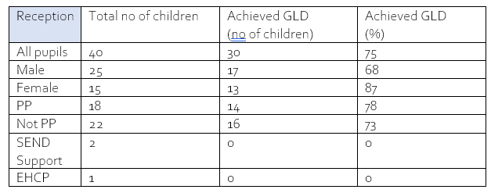
- National GLD for 2025-2026 was 72%
YEAR 1 PHONICS SCREEN – SUMMER 2026
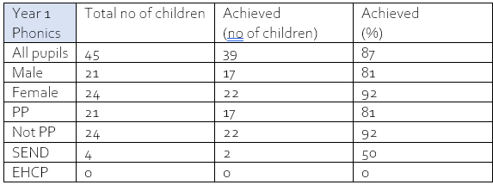
- National Year 1 Phonics pass rate for 2025-2026 was 82%
END OF KEY STAGE 1 OUTCOMES – SUMMER 2026

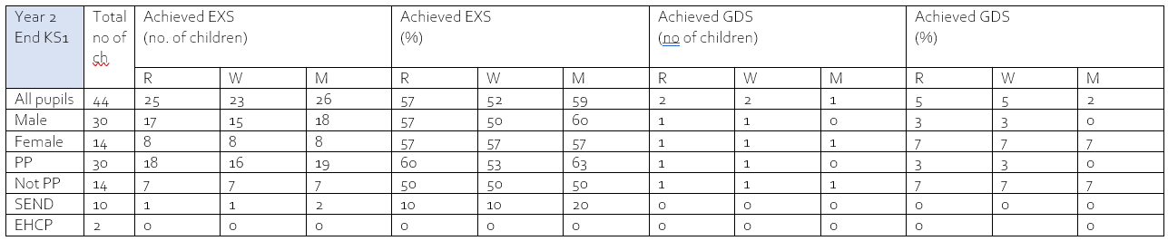

END OF KEY STAGE 2 OUTCOMES – SUMMER 2026

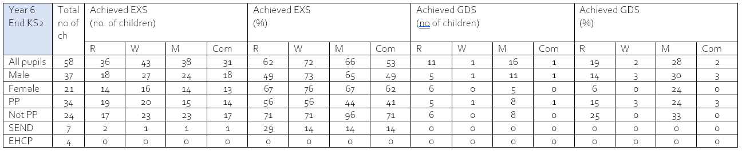
NARRATIVE:

- 37 boys and 21 girls
- 4 children with EHCPs
- Writing is out of 60 as teacher assessed. All other scores out of 58 with 2 disapplied.
- There were 15 changes to pupils during the year.
- 4 new arrivals from outside of the UK. 2 were successfully disapplied, 2 were not despite not having English as a first language.
- Over 60% of the children scored over 30 out of 40 in the arithmetic test i.e. over 75%
- GDS was above National average at 28%
- Language for thinking interventions every morning for 30 mins with groups:
- 5 children within 2 marks for Reading Comprehension test.

Externally provided programmes
Please include the names of any non-DfE programmes that you used your pupil premium to fund in the previous academic year.
Programme | Provider
TT Rockstars | Maths Circle

