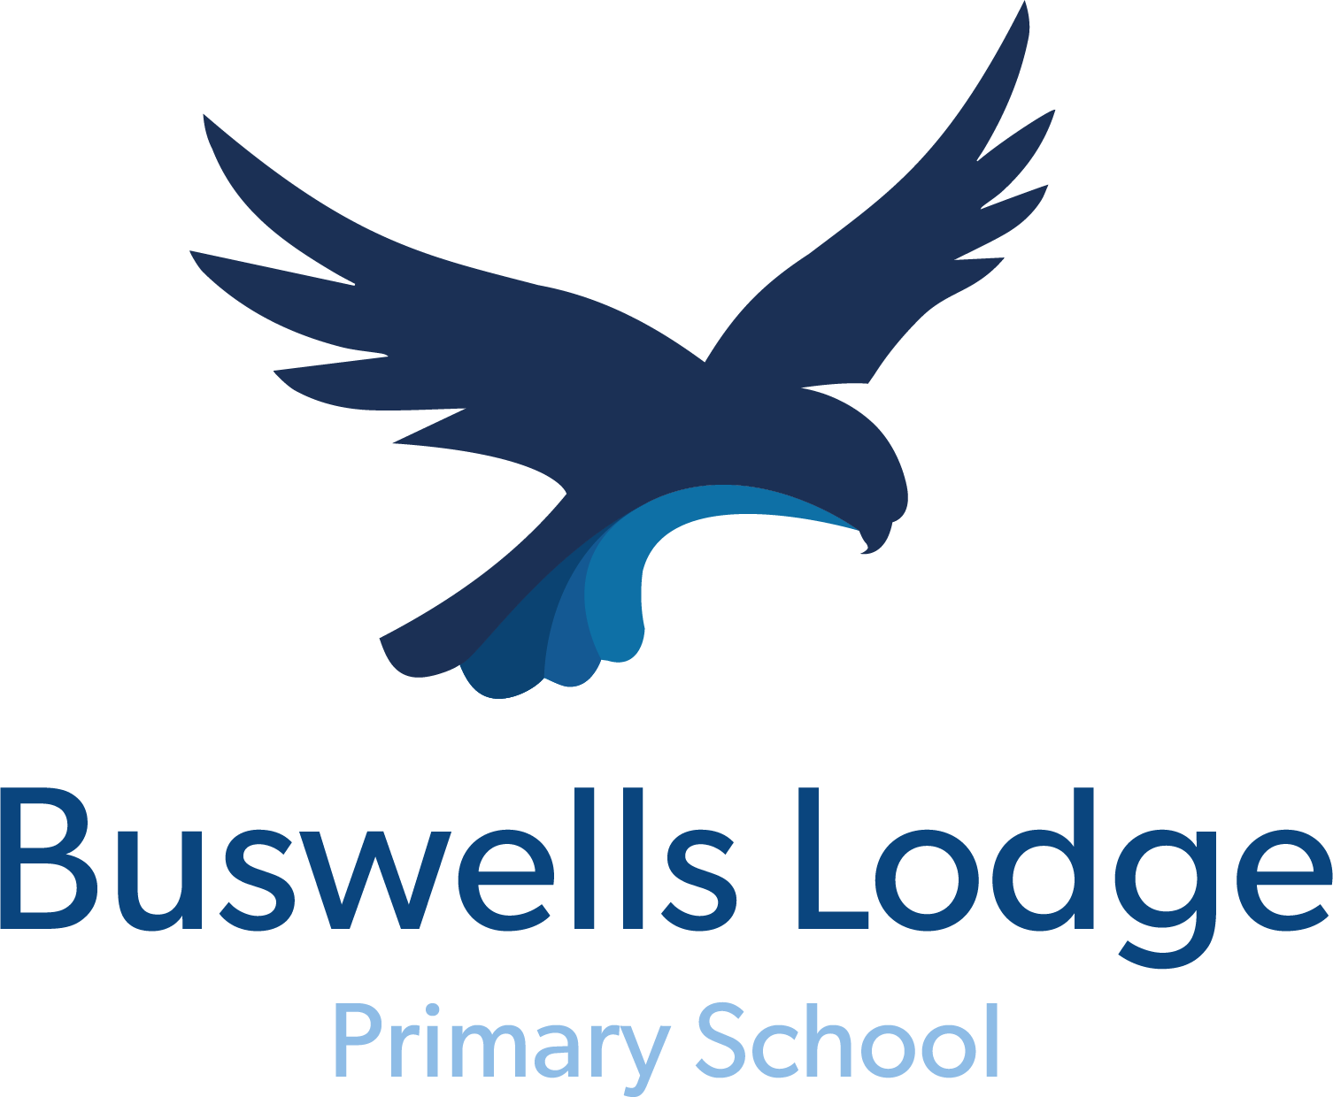

Uniform Policy

Headteacher: Mr Adrian Durrant Chair of Governors: Ms L Wyeth

Date: September 2026 To be reviewed: September 2029

SCHOOL UNIFORM POLICY

The Governing Body wants the children at Buswells Lodge Primary School to be proud of being part of our School. We believe that wearing a school uniform enhances this feeling of belonging and encourages an attitude in the school that supports high standards in learning and presentation.

We believe that school uniform:

- promotes a strong, cohesive, school identity that supports high standards;
- instils pride;
- supports positive behaviour and discipline;
- encourages identity with, and support for, school ethos;
- ensures pupils of all races and backgrounds feel welcome;
- protects children from social pressures to dress in a particular way;
- nurtures cohesion and promote good relations between different groups of pupils;
- supports effective teaching and learning

Pupils are expected to follow this uniform code.

- All items worn to school should be plain (apart from school logo)
- Pupils' clothing should be named to assist both children and staff when items are mislaid

OUR SCHOOL DRESS CODE:

Our school colour is Royal Blue

- Black or dark grey trousers / skirt / pinafore
- White or blue polo shirt
- Royal blue sweatshirt
- In the summer, the wearing of light blue gingham dresses would also be acceptable
- Sensible footwear is also required, preferably in black. Shoes with heels/platform soles, open toed sandals, or ‘sling back’ shoes etc. are not appropriate for school wear and can lead to injuries

For safety reasons we ask that children do not wear jewellery in school. This includes nose studs or earrings of any kind. Children with pierced ears should only wear studs during the day. For the first six weeks only, following ear piercing, studs must be covered using plasters which the parent must provide during PE and games activities, after which time they must be removed.

All jewellery worn for a religious significance must be covered up safely by a sweatband or other similar covering. All jewellery, to include watches brought into school, is at the child’s/parents own risk. The school accepts no responsibility for any loss of jewellery.

Hair accessories such as slides, ribbons, bobbles etc. should be simple and if possible in school colours.

No make-up, including nail varnish should be worn.

Children in the Foundation Stage are encouraged to bring a pair of wellies to keep in school for outdoor learning and play.

PE KIT

For health and safety reasons it is important that children are dressed properly for any physical activity. Children should come to school on their PE day wearing their PE kit.

Children should wear black tracksuit or shorts, a plain T-shirt and suitable trainers.

A suitable jumper or tracksuit top may be required for outdoor activities during the colder weather. For some activities, sturdy trainers or football boots may be required.

PURCHASING SCHOOL UNIFORM:

The most cost-effective place to buy uniform is in a major supermarket, which usually stock a wide range of sweatshirts in our school colour, trousers, skirts, shirts and polo shirts.

Items of clothing bearing the school logo can be bought from:

Uniform Direct
54-56 Humberstone Gate
Leicester
www.uniform-direct.com

LOST PROPERTY

All items of lost property are kept in Ideas HQ. Please contact the school office should an item go missing. Please mark all school uniform with your child’s name so that any lost items are easy to locate and return.

At the end of each half term, all lost property is sent to our charity partner, LCH, who launder and return branded items and keep non-branded clothing to distribute via their charitable organisation. Once this collection has happened, it is not possible for any non-branded items to be returned.

Policy updated: September 2026
To be reviewed: September 2029

