

SEND Information Report

Reviewed: October 2025
Review Date: October 2026
Ethos, Values and Vision
Welcome to our Special Educational Needs and Disabilities (SEND) Information Report, which is part of the Leicester City Local Offer (LCLO) for learners with SEND. The Local Offer has been produced by the Local Authority (LA) in collaboration with Leicester City schools.
At Buswells Lodge Primary School, we are committed to working together with all members of our school community. Our children, staff and parents and/or carers work actively in partnership to enable all children to realise their potential. Our school is an inclusive school where every child matters. We address children’s needs and support their development in the most appropriate way possible; celebrating effort as much as achievement. Our school’s SEND Policy document is available on our school website. Please follow the link below to find this.
Buswells Lodge SEND Information

Who is the SEND Coordinator?
Our Special Educational Needs and Disabilities Coordinator (SENDCo), James Perry, has worked in the school for over seven years, and is currently studying towards the NPQ for SENDCos. In order to maintain a local and national perspective of current SEND practice and procedure, the SENDCo regularly attends Local Authority network update meetings and training, and is an active member of both the Attenborough Learning Trust (ALT) and local schools’ SEND Development Groups.

The SENDCo is supported by the SEND link Governor, Roy Weller, who monitors SEND provision throughout our school.

What kinds of SEND does the school cater for?
Additional and/ or different provision is currently being made in school for children with a range of needs, including;
- Communication and interaction (such as Autism and speech and language difficulties)
- Cognition and learning (such as dyslexia, dyscalculia, and dyspraxia, moderate learning difficulties, and global developmental delay)
- Social, emotional, and mental health (such as ADHD (Attention Deficit Hyperactivity Disorder), attachment disorders, and emotional and/or mental health difficulties)
- Physical and sensory (such as vision, hearing and/or sensory processing difficulties)

Please follow the link below for further information regarding this.

Types of SEND

What does Buswells Lodge do if they think my child may have SEND?
Children with SEND are identified by following the Leicester City graduated approach as detailed below. In order to be identified as having SEND, a child will need to complete several cycles of the Leicester City graduated approach, with little or no progress being made. Please follow the link below to find this.

Leicester City Graduated Approach

Quality First Teaching is provided for all children at Buswells Lodge. The progress of all our children is monitored at pupil progress, intervention, and SEND review meetings. If there are concerns about enduring progress, a child may be placed on Early Monitoring. During this period of Early Monitoring, staff utilise strategies and adjustments, based on identified areas of need, using the Leicester City BERA Framework. Please follow the link below to find this.

Leicester City Best Endeavours and Reasonable Adjustments (BERA) Framework

This Early Monitoring phase is detailed in Stage 1 of the diagram below.
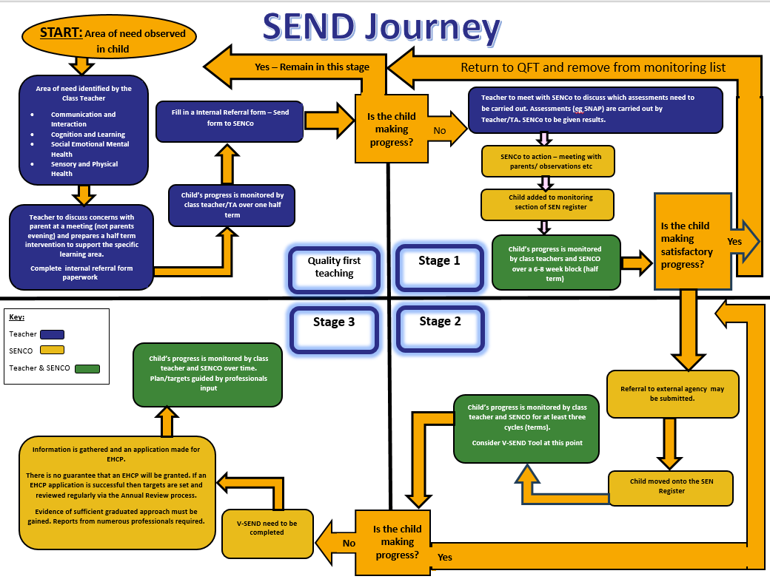

In order to identify the needs of a child, the SENDCo, or other trained staff, may need to undertake a range of standardised assessments with a child. These standardised assessments add to and inform class teachers’ own assessments of a child. The outcomes of these standardised assessments allow class teachers and/or other staff to employ personalised support to meet the needs of the child.

Although the school can identify and make provision to meet SEND, we are not medically qualified to diagnose. Parents and/or carers are advised to contact their child’s General Practitioner (GP) if they believe that their child may have additional needs and/or underlying medical or health-related conditions or disabilities which require a medical diagnosis. The school are happy to offer advice and provide letters to support parents and/or carers with this.

What should I do if I think my child may have SEND?
When they are concerned, parents and/or carers often ask us to look more closely at their child’s progress. We take all requests seriously and investigate them all. Frequently, these concerns can be addressed by Quality First Teaching along with some parental and/or carer support. If the school deems it necessary, the same graduated approach as above will be implemented by the school.

If you think your child may have SEND;
- Speak to your child’s class teacher to see whether they share your concerns. They will be able to offer you advice and strategies on how they are currently supporting your child in school. They will also suggest ways in which you can support your child in their learning.
- If you continue to have concerns, please make an appointment to see the SENDCo. This can be done by phoning or visiting the school office.
- If you have a medical or health-related concern about your child, which you feel may impact their learning and development, please make an appointment to see your child’s GP or speak with an appropriate medical professional. If your child’s GP or other medical professional shares your concerns, please relay this information to the SENDCo by phoning or visiting the school office. Where possible, the SENDCo will support parents and/or carers with this.

Please follow the link below for further information regarding this.

Think your child has SEND?

How will Buswells Lodge support my SEND child?
If a child’s progress does not improve after several cycles of the Leicester City graduated approach, a child may be placed on the school’s SEND register at SEND level. At this stage, a discussion will be held with parents and/or carers, and formal confirmation of this will be made by letter.

In line with the SEND Code of Practice (2014), class teachers continually monitor the SEND journey of children in their class with the support of the SENDCo. This is detailed in Stage 2 of the diagram above. Class teachers will continue to refer to and implement the Leicester City BERA Framework. If progress continues to remain limited, the school may apply for Special Educational Needs Inclusion Funding (SENIF) or Element 3 additional funding, or a statutory assessment to provide the funding required to provide educational opportunities above those covered by the school’s Notional SEND Budget.

SENIF and Element 3 Funding

If a statutory assessment is agreed by the LA, a thorough assessment (EHCNA) of the child’s educational and health needs will be completed. This may result in the child being awarded an Education and Health Care Plan (EHCP), which provides some additional funding to support the child in school. This is detailed in Stage 3 of the diagram above.

Statutory Assessment (EHCNA)
Education and Health Care Plans (EHCPs)

Quality First Teaching is provided for all children at Buswells Lodge. Those children who require additional support, whichever stage of the graduated response they sit at, may receive this additional support in the forms below.

- Quality First Teaching
High-quality teaching that is adapted and personalised will meet the individual needs of the majority of children and young people. We believe that all children learn best with the rest of their class. Our aim is for all children to be working independently in class with their peers. Children with SEND are to be taught by their own class teacher unless they are placed in the school’s Internal Alternative Provision (IAP).

- Additional adult support
When allocating additional adult support to children, our focus is on outcomes, not hours. We aim to offer sufficient support to enable the child to reach their personalised outcomes without developing a learned dependence on an adult.

- Targeted interventions
The school makes use of a range of interventions. When considering interventions, we focus on a child’s needs and personalised outcomes, and target the child with interventions which are best matched to support these. Interventions are crucial in closing gaps in learning. They are monitored closely by both the class teacher (who monitors progress towards the child’s personalised outcomes) and by the SENDCo (who monitors overall progress after the intervention). If interventions are proving to be ineffective, they will be stopped and alternatives investigated.

- Record keeping
The school keeps a variety of records for all children, including those with SEND. These may include:
- Education and Health Care Plans (EHCPs)
- Pupil Outcome Plans (POPs)
- Intervention Records
- School-Based Assessments (SBAs)
- Medical and Intimate Care Plans
- Personal Emergency Evacuation Plans (PEEPs)

Please follow the link below for further information regarding this.

School support for children and young people with SEND

- Internal Alternative Provision (IAP)
In order to fully support the needs of children at our school who are waiting for a place at either a special school, or a designated specialist provision (DSP), the school has introduced an IAP. This provision has a defined ‘Entry and Exit’ criteria which is available on the school website. The children who attend this provision require a bespoke curriculum which is tailored to meet their more complex educational needs. Both the school and parents and/or carers must be in agreeance before a child can be placed in this provision.

Please follow the link below to see the school’s Entry and Exit criteria for the IAP.

Buswells Lodge SEND Information

How will the curriculum be matched to my child’s needs?
All of our children access the National Curriculum at their level of learning. As a school, we recognise and celebrate achievement and expertise in all curricular areas. Our curriculum is adapted by class teachers who use quality first teaching to meet the varying needs and learning styles of our children. Class teachers plan lessons with appropriate scaffolds, visuals and resources and additional adult support is used flexibly to promote independence and inclusion.

What support will be available for my child’s overall well-being?
Our school is a caring and nurturing environment. Our staff work diligently to build relationships with children and parents and/or carers so that children have trusted adults who they feel can, and will support them.

If your child is felt to have Social, Emotional or Mental Health (SEMH) needs, the school offers social skills interventions, morning meet and greet and nurturing provision. We are also extremely lucky to have a trained Emotional Literacy Support Assistant (ELSA) and a Learning Mentor who is qualified in bereavement and ‘Drawing and Talking’ therapies.

Buswells Lodge uses Zones of Regulation to allow children to emotionally ‘check-in’ throughout the school day. Class teachers monitor these during the day, and the school ELSA and Learning Mentor provide twice-daily targeted check-ins during registration sessions.

Our Family Support Worker can support you with issues at home, possibly through a referral for an Early Help assessment, and health needs can be met by the School Nurse or your Health Visitor (if your child is under 5). An Educational Welfare Officer (EWO) will support you with your child’s school attendance if required.

All children's behaviour is responded to consistently in line with our Behaviour Policy, although reasonable adjustments are made to accommodate individual needs. The school has a zero-tolerance approach to bullying, especially towards children with SEND. We will actively investigate all allegations and, if there is cause, work with both the victim and the bully using restorative practices.

Please follow the link below for further information regarding this.

School support for children and young people with SEND

How will both you and I know how my child is doing?
Buswells Lodge reviews pupil progress at termly meetings between class teachers, and members of the senior leadership team (SLT). Those children who have been placed on Early Monitoring, will have their progress more closely monitored by the class teacher and SENDCo. Children receiving additional support in the form of interventions, will have their progress within the intervention monitored. If interventions are proving to be ineffective, they will be stopped and alternatives investigated.

Termly meetings will be offered to the parents and/or carers of those children who are already on the SEND register. Meetings in the Autumn and Spring terms will take place with a child’s class teacher. An appointment with the SENDCo will be offered in the Summer term. During these meetings, the class teacher or SENDCo will review a child’s Pupil Outcome Plan (POP). This will include a review of:
- current attainment
- academic progress
- progress towards personalised SEND outcomes
- interventions

A written end of year report will be sent at the end of the Summer term. Other meetings may be scheduled throughout the year and parents and/or carers are welcome to discuss their child at a pre-arranged time that suits both the parents and/or carers and the class teacher and/or SENDCo.

If your child has been awarded an EHCP, an annual review meeting will also be held in order to assess their current provision and outcomes, and update these accordingly. Where appropriate, external professionals who have supported your child may also be involved in these reviews.

What training have staff had in supporting children with special educational needs?
All of our class teachers are trained to work with children with SEND and have access to advice, information, resources and training to enable them to teach all children effectively. We offer training and self-help opportunities through access to in-house, LA and online training. Recent training includes, but is not limited to:
- Autism Education Trust (AET) Level 1
- AET Framework and assessment
- trauma and adverse childhood experiences (ACEs)
- Zones of Regulation
- Team Teach (identified staff)
- hearing impairment (identified staff)

Our teaching assistants (TAs) have expertise and training in certain areas of SEND or specific interventions. Some of the additional SEND support and/or interventions that we have available are:
- ELSA
- bereavement support
- Drawing and Talking
- nurture provision
- Let’s Talk
- Colourful Semantics
- Literacy Gold
- Toe by Toe
- Beat Dyslexia
- 123 Maths
- Play Interaction
- Attention Autism
- social stories
- WIDGIT
- Picture Exchange Communication System (PECS)

Who can Buswells Lodge contact if they need extra support or advice with helping my child?
The school is able to access more specialist help and additional expertise from the LA. This includes support from education, health and social care professionals such as:
- Educational Psychologist (EP)
- Learning, Communication and Interaction Team (LCI)
- Social, Emotional and Mental Health Team (SEMH)
- Speech and Language Therapy Service (SALT)
- Early Years Support Team (EYST)
- Vision Support Team (VI)
- Hearing Support Team (HI)
- School Nurse
- Health Visitor (if your child is under 5)
- Medical support services including physiotherapists (PT), occupational therapists (OT) etc.
- Education Welfare Officer (EWO)

How accessible is the school environment? What facilities or equipment are available?
The school is single story, the corridors are wide and we have disabled parking bays. When required, we make adaptations to the environment and/or building that are necessary to support children with physical and/or other sensory difficulties. Other accessibility features include, but are not limited to:
- accessible toilet and changing facilities
- dual sound and light alarm system to support visual and hearing-impaired pupils, staff and visitors
- library shelves at wheelchair-accessible height
- audio versions of SEND related policies on the school website

We pride ourselves on being an inclusive school. All of our classrooms are as communication-friendly and visually supportive as they can be, and we aim to provide universal provision for all children. This is good practice to support all children, but is vital for those who need it. This includes, but is not limited to:
- reduced and communication friendly classroom displays
- communication friendly interactive whiteboard slides
- buff modelling books and paper
- whole school WIDGIT visuals
- whole class WIDGIT visual timetables
- objects of reference
- working walls
- word banks
- talk tins
- word adaptations
- work scaffolding
- physical/concrete manipulatives
- ear defenders
- flexible seating and grouping arrangements

Some children may require additional provision in order to support their additional needs, and ensure that they can access the curriculum. This may include, but is not limited to:
- Personal Emergency Evacuation Plans (PEEPs)
- individual visual timetables
- now and next boards
- adapted technology
- talk to type software
- reading software
- interactive whiteboard mirroring
- Sound field audio systems
- access to the school’s sensory space
- access to quiet spaces
- sensory equipment
- adapted materials
- large print resources
- buff exercise books and paper
- ergonomic writing tools
- specialist seating
- ear defenders

For further details, the school Accessibility Plan is available on the school website.

Please follow the link below for further information regarding this.

Buswells Lodge SEND Information

How will my child be supported with exams?
Exam access arrangements are used to support children who need additional provisions when taking an exam.

Access arrangements may be appropriate for children:
- with an EHCP
- for whom provision is being made in school using the SEND support system
- whose learning difficulty or disability significantly affects their ability to access the tests
- who have behavioural and/or social and emotional difficulties

Access arrangements might also be used to support children who have:
- difficulty reading
- difficulty writing
- difficulty concentrating
- difficulty processing information
- a visual impairment
- a hearing impairment
- English as an additional language (EAL)

The decision to disapply a child from an exam can only be made by the headteacher. This is a rare occurrence and should only be considered when a child is working significantly below the standard of the test, to the point where they would not be able to score any marks. If this is relevant to your child, your child’s class teacher will discuss this with you.

How will I be involved in supporting my child?
You will be invited to attend parents’ and/or carers’ meetings with your child’s class teacher in both the Autumn and Spring terms. In the Summer term, parents and/or carers of children on the SEND register will receive an additional appointment offer with the SENDCo.

You can support your child’s learning and development in other ways, including:
- Attending whole school events and celebrations
- Attending weekly achievement assemblies
- Supporting your child at school sports events
- Coming to school information events
- Support your child regularly with their reading, spellings, times tables and other home learning opportunities
- Become a parent and/or carer governor
- Join the school’s active Parents, Teachers and Friends Association (PTFA)

How is my child involved?
We encourage all children to be actively involved in their learning, and staff are committed to working in partnership with children and their families to provide the best learning experience possible.

If your child has been awarded an EHCP, they will be invited to attend their annual review meetings. If they are not capable, or do not feel comfortable to do so, we will use visuals or other child-friendly tools to gather their opinions on school. Those children who are in receipt of additional funding will be asked to give their opinions on school as part of the application process. This gives school an indication of how to best support the child’s needs with the additional funding that they have received.

How will my child be supported with moving classes, year groups or to another school?
All children, regardless of race, faith, gender or capability in all aspects of school are welcome at Buswells Lodge, in line with the LA Schools Admissions Policy.

Transition into and within school:
We understand how difficult transitions can be for children and their parent and/or carers. We will do what we can, according to the individual needs of the child, to make transitions between schools and classes as smooth as possible. This may include:
- Additional meetings with the new class teacher for the child and parents and/or carers
- Additional visits to the new classroom environment for the child to gain familiarity
- A transition leaflet including photographs of new key adults and locations

Transition to Secondary School:

Each year, transition meetings will take place in the Summer term between the Buswells Lodge SENDCo and local secondary school SENDCos. Each child on the SEND register will be discussed, and current EHCPs and POPs will be shared with new schools. Enhanced transition arrangements may be made at these reviews (extra or longer visits) and are tailored to meet children’s individual needs. At times, depending on the needs of the children involved, school staff may accompany children on these visits.

Supporting the move from primary to secondary

How will my child be included in activities outside of school, including educational visits?
All of our children have equal access to before-school, lunchtime and after-school clubs. Where required, we make adjustments and adaptations to meet the physical and learning needs of our children who attend these clubs.

Class educational visits are part of our curriculum and we aim for all children to benefit from them. No child will be excluded from an educational visit because of SEND, or medical needs. If it is felt that a child may pose a risk to themselves or others as part of an educational visit, a risk assessment will be completed, and the outcomes shared and discussed with parents and/or carers.

What can I do if I am worried, unhappy with something, or I need to make a complaint?
The school works in partnership with parents and/or carers to ensure a collaborative approach to meeting every child’s needs. If you have a concern, please bring this to the attention of your child’s class teacher, who will then liaise with the school SENDCo. If you are still unhappy with the outcome, please contact the Head teacher or Chair of Governors via the school office - details below.

Should you wish to make a formal complaint, you must do this in writing. All complaints are taken seriously and are heard through the school's complaints policy and procedure. A copy of this document can found on the school website and is available at the school office.

Name | Adrian Durrant | Lynn Wyeth
Role | Head teacher | Chair of Governors
Contact Details | 0116 2352129  Buswells Lodge Primary School  Beauville Drive  Leicester  LE4 0PT
Who else can support me and my child?
In addition to the services provided by the LA, you may wish to seek support from voluntary and charitable agencies including:
- SENDIASS (Special Educational Needs and Disabilities Information, Advice and Support Service)
- IPSEA (Independent Provider of Special Education Advice)
- Chat Autism
- ADHD Affinity
- Deaf Children's Society
- The Laura Centre (bereavement)
- NSPCC
- Barnados

Please follow the link below for further information regarding these services.

Buswells Lodge SEND Information

‘My Choice’ is a directory for care and support products and services for people living within the Leicester City area and is an invaluable source of support.

My Choice Leicester City

Report Compliance
This report is compliant with the following legislation:
- Section 69 (2) of the Children and Families Act 2014
- Regulation 51 and Schedule 1 of the SEND regulations 2014
- Section 6 of the SEND Code of Practice 0-25

